Lab 5
Supplier
SupplierID | Name | Address
S01 | ABC Company | Penang
S02 | XYZ Company | Johor
S03 | HJK Company | Selangor
S04 | PQR Company | Selangor

Primary key: SupplierID

Product_P
ProductID | Name | Price_RM | QuantityInStock
P01 | Keyboard | 103.55 | 60
P02 | Mouse | 30.90 | 70
P03 | Monitor | 200 | 80
P04 | Pendrive | 40.30 | 50
P05 | Mouse (wireless) | 45.50 | 25

Primary key: ProductID

Supplies
SuppliesID | SupplierID | ProductID | SuppliedDate | QuantitySupplied
001 | S01 | P01 | 11/ 1/2023 | 70
002 | S01 | P02 | 22/2/2023 | 20
003 | S01 | P03 | NULL | 55
004 | S02 | P03 | 26/2/2023 | 20
005 | S04 | P05 | 1/3/2023 | 25
006 | S04 | P02 | 1/3/2023 | 35

Primary key: SuppliesID
Foreign Key: SupplierID, ProductID

- Using Ms SQL Server, create a new database Lab5
- Write query to create the tables given above
- Write query to add each row of data into the tables

Attributes | Data Type
SupplierID | nvarchar(50)
Name | nvarchar(50)
Address | nvarchar(50)

Attributes | Data Type
ProductID | nvarchar(50)
Name | nvarchar(50)
Price_RM | decimal(10,2)
QuantityInStock | integer

Attributes | Data Type
SuppliesID | nvarchar(50)
SupplierID | nvarchar(50)
ProductID | nvarchar(50)
SuppliedDate | date
QuantitySupplied | integer

Reference:
https://www.w3schools.com/sql/default.asp

- Generate the database diagram
If you are using Lab PC (or if you’re not using the Admin account), execute the statement below (no need to execute if you’re using own PC/using admin account), this is to grant Admin access to the functions to create database diagram

Alter Authorization on Database::Lab3 To [sa];
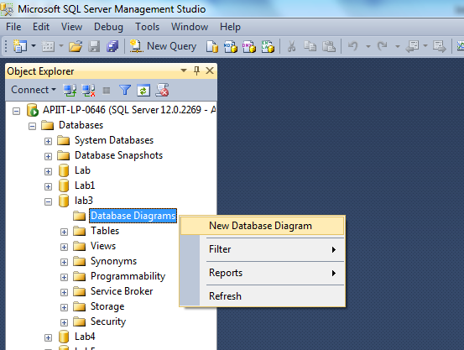

- Using SQL ‘Select’:
  - Display data from all columns from the supplier table SELECT * FROM…..
SELECT * FROM Supplier;
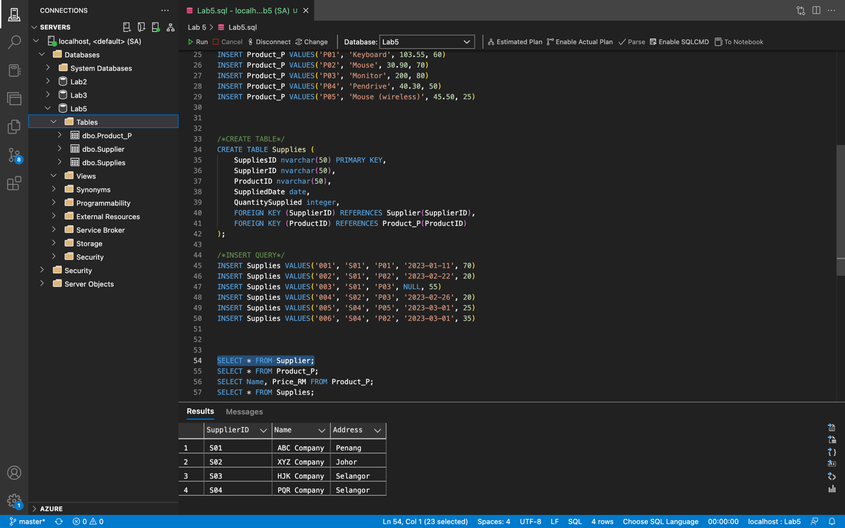

  - Display only product name and price from product table SELECT ……. FROM…
SELECT Name, Price_RM FROM Product_P;
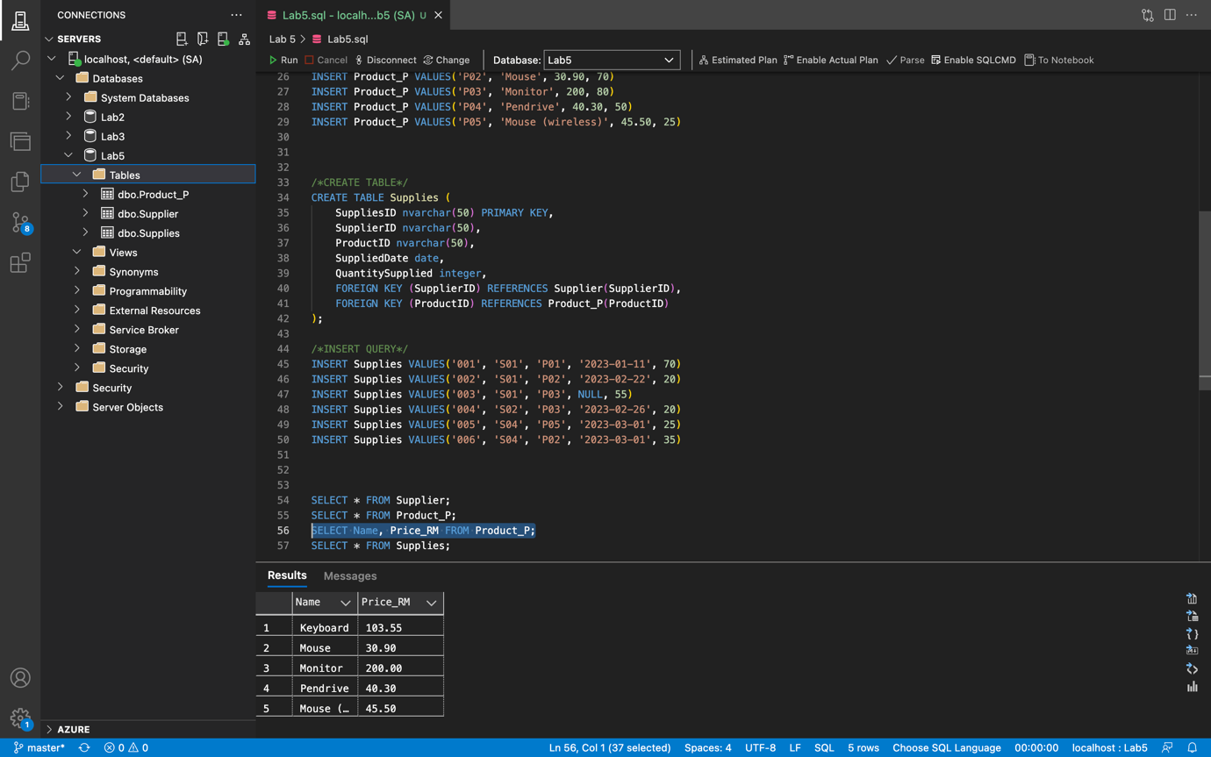

- Using SQL ‘Select Distinct’:
  - Display only the DISTINCT values from the "Address" column in the Supplier table SELECT DISTINCT….FROM….
SELECT DISTINCT Address FROM Supplier;

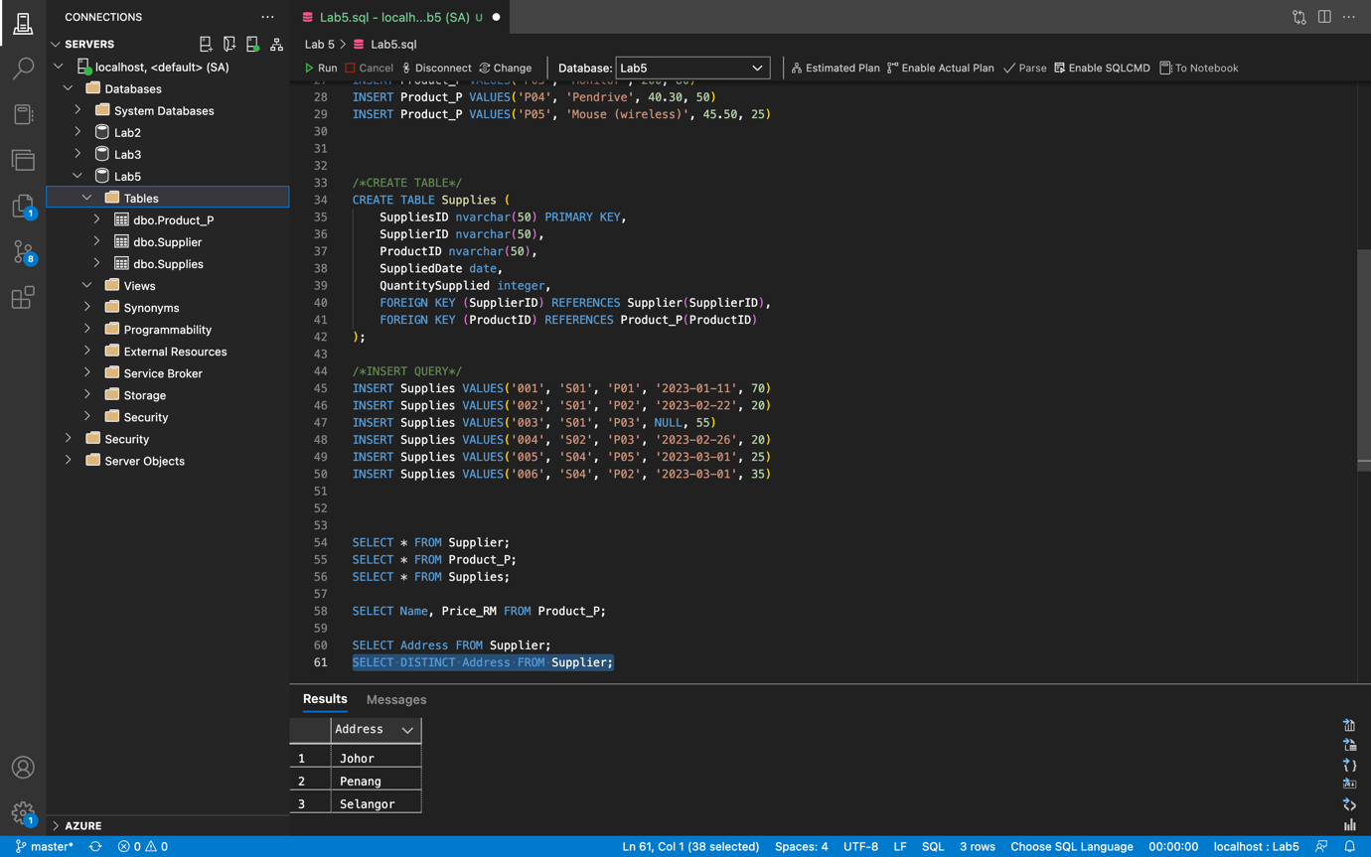

- Using SQL ‘IS NULL’, ‘IS NOT NULL’
  - Display all records from Supplies table where SuppliedDate is a null
SELECT * FROM Supplies WHERE SuppliedDate IS NULL;
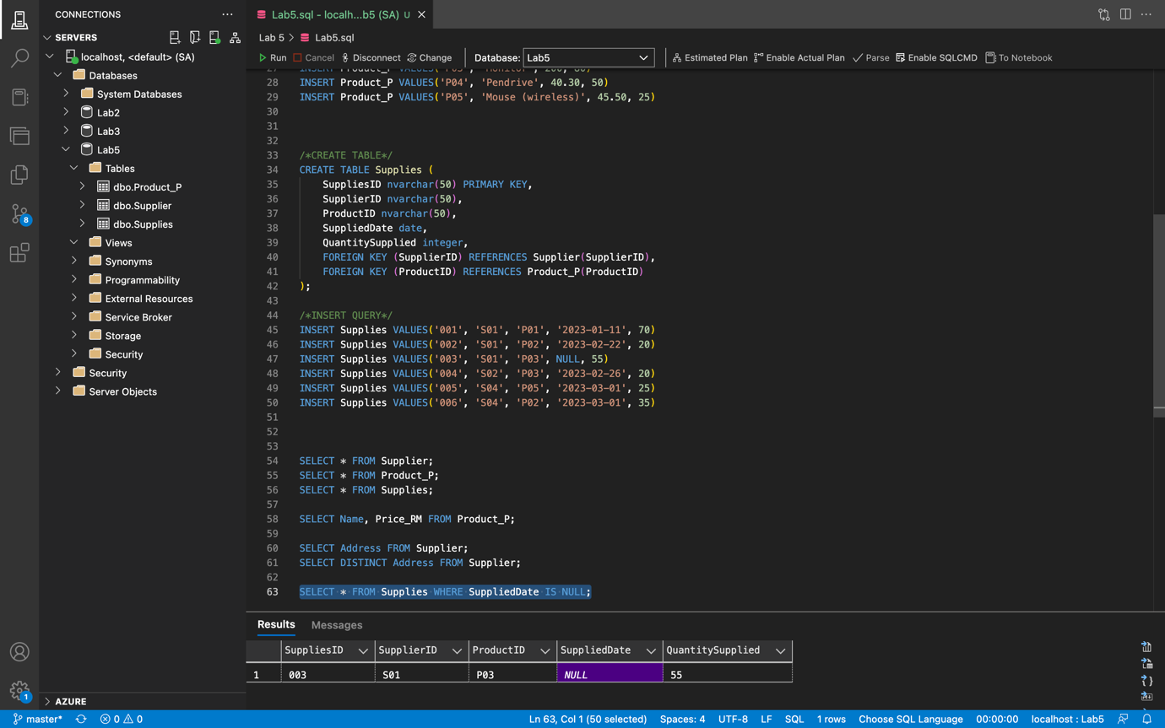

  - Display all records from Supplies table where SuppliedDate is not a null
SELECT * FROM Supplies WHERE SuppliedDate IS NOT NULL;
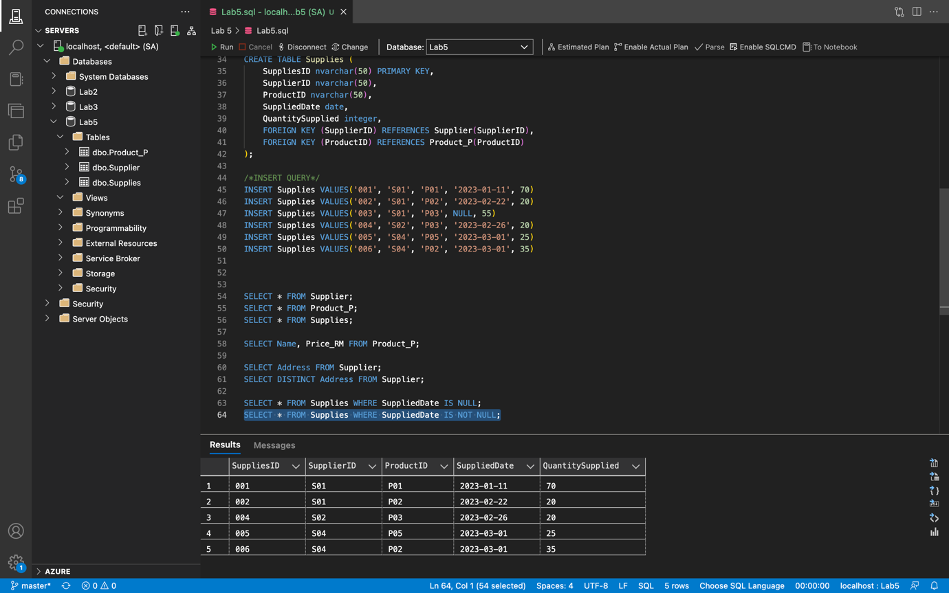

- Using SQL ‘Where’
  - Display all suppliers from Selangor
SELECT * FROM Supplier WHERE Address='Selangor';
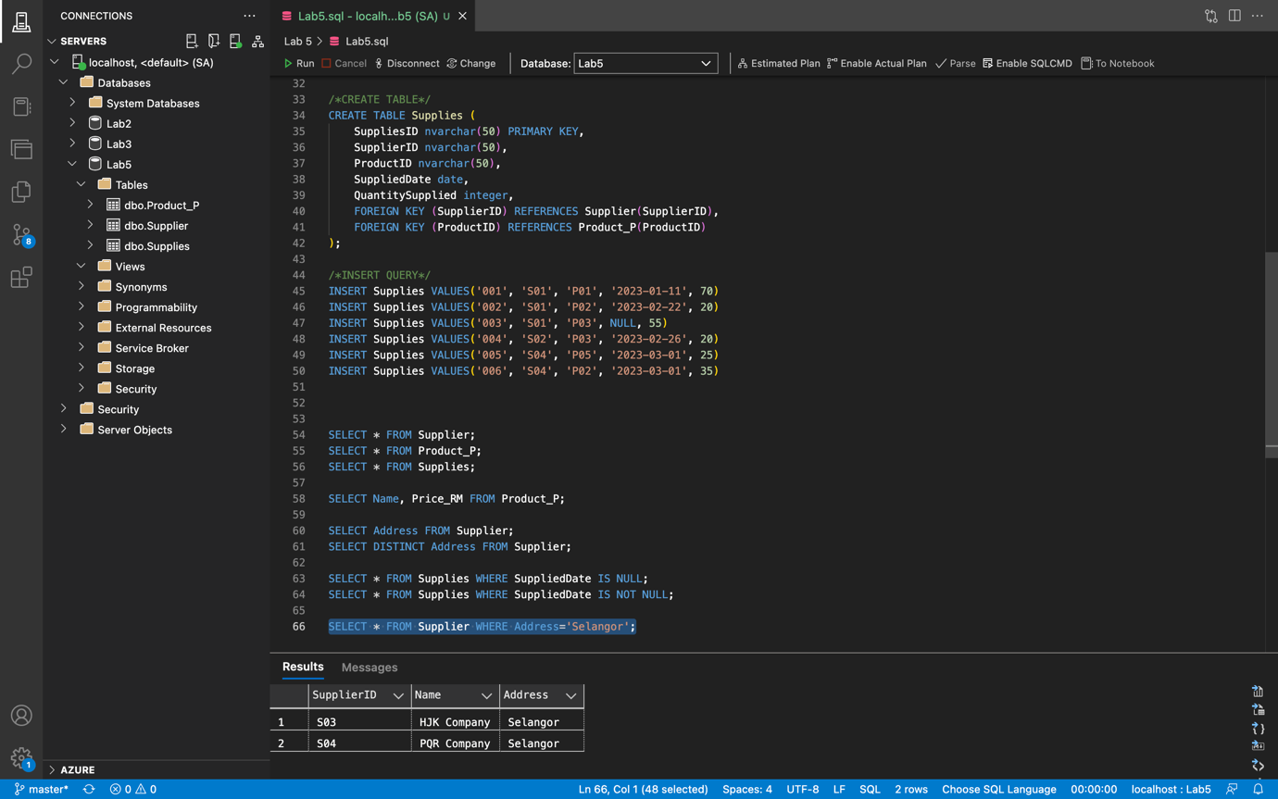

  - Display all products supplied by supplier with supplierID S01.
SELECT SupplierID, Name, Product_P.ProductID, Price_RM, QuantityInStock FROM Supplies
INNER JOIN Product_P
ON Product_P.ProductID = Supplies.ProductID
WHERE SupplierID = 'S01';
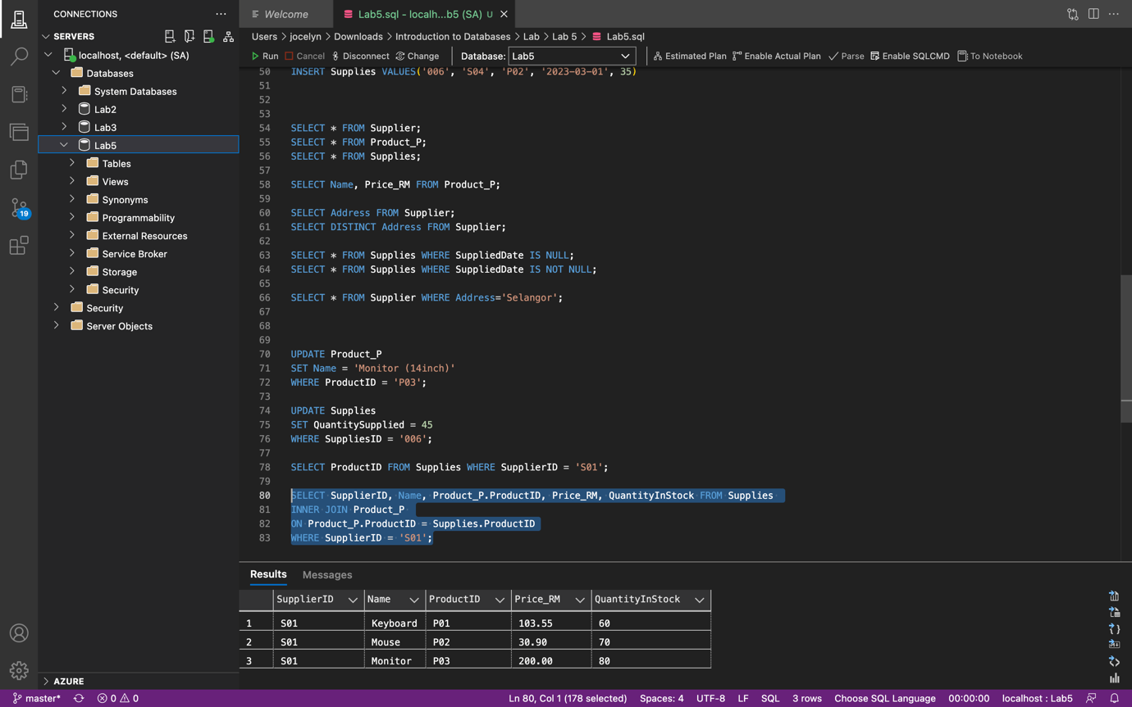

SELECT ProductID FROM Supplies WHERE SupplierID = 'S01';
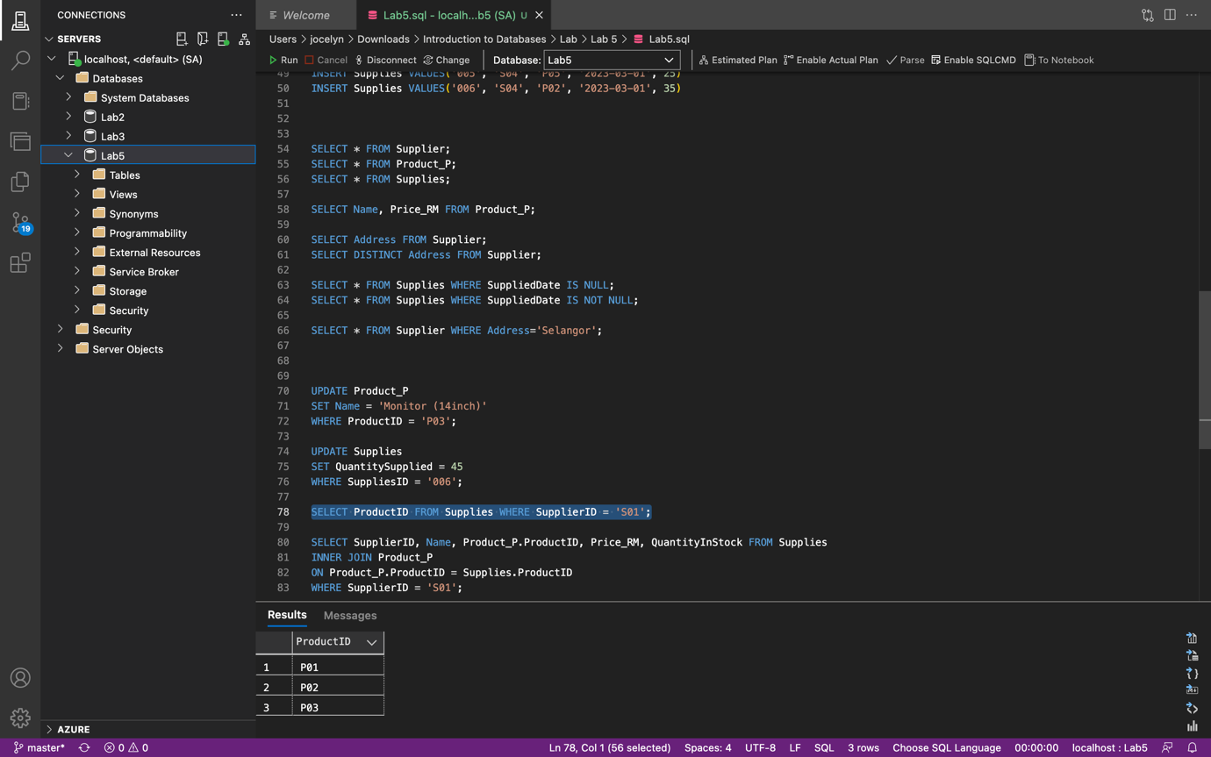

- Using SQL ‘Update’
  - Change value in column Product.Name from ‘Monitor’ to ‘Monitor (14inch)’
UPDATE Product_P
SET Name = 'Monitor (14inch)'
WHERE ProductID = 'P03';

SELECT * FROM Product_P;
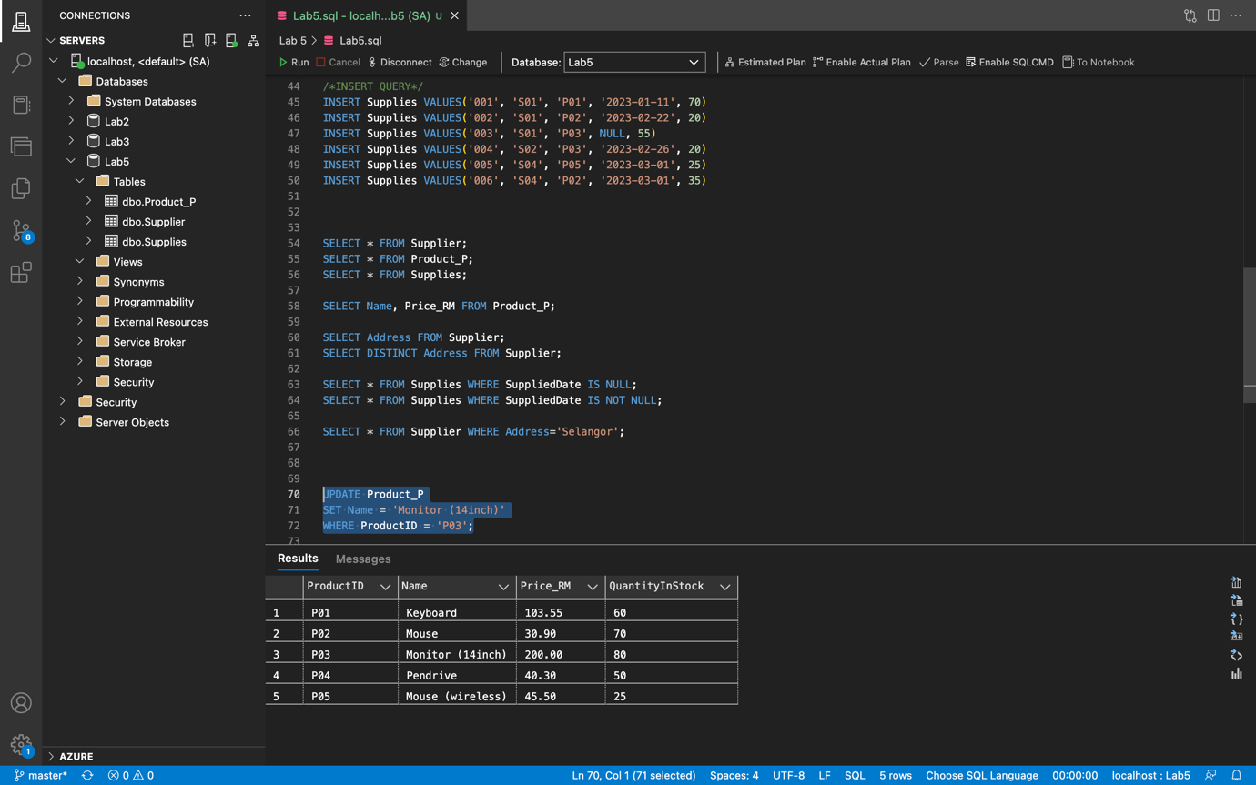

  - Change value in column Supplies.QuantitySupplied from ‘35’ to ‘45’ for SuppliesID=006 UPDATE ….. SET<column_name> = <new_value> WHERE…..
UPDATE Supplies
SET QuantitySupplied = 45
WHERE SuppliesID = '006';

SELECT * FROM Supplies;

